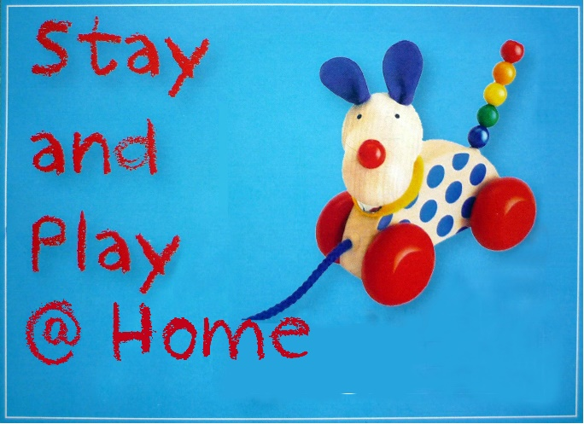

Name of Parent……………………………………………………………………

Address: ...................................................................................................................

Email: ……………………………………… Phone: .............................................

Name of Carer (if not the above) …………………………………………………

Address……………………………………………………………………………

Email: ………………………………….……Phone: …………………………….

Emergency Contact…………………………………………………………………

Child(ren) Name(s), Age(s), Date/s of birth and any allergies

..................................................................... ............................................................

..................................................................... .............................................................

…………………………………………… ……………………………………….
Use of Children’s photos
Stay and Play is recorded through visual images for historical and promotional purposes. These images may be used in electronic media or print materials . If the image of any Stay and Play child cannot be used in any promotional material, Parents and Carers are asked to notify Joy Stewart via email at bruceandjoy@bigpond.com

NO NAMES WILL BE USED IF PHOTOS ARE USED

This information is collected and stored in accordance with the Uniting Church SA Privacy Policy for the primary purpose of Stay and Play @ Home, an activity of Athelstone Uniting Church.
We will seek your permission before sharing your information for secondary purposes.

Signature: ………………………………………………Date: / /

