Research on knitting
Have you in the last few years been involved in knitting for a Christian church or organisation (e.g. Common Grace Knit For Climate Action or Christmas Angels)?
Are you aged over 18 years?
Would you be willing to participate in research on why you knitted and what it meant to your faith and spirituality?
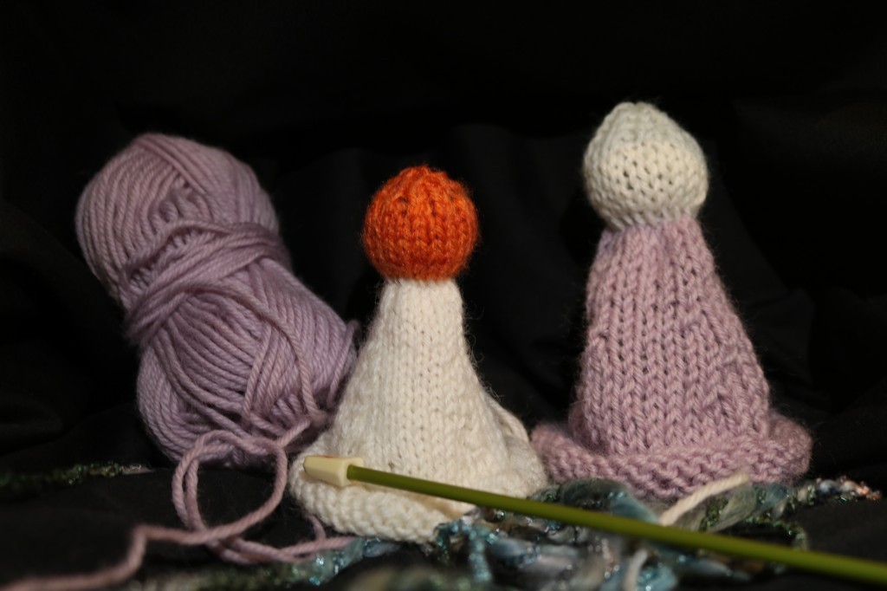
Researchers from Adelaide College of Divinity are seeking participants for research on knitting in Christianity. If you are aged over 18 years and have been involved in a knitting project like Common Grace Knit For Climate Action or Christmas Angels and are willing to be interviewed about your experiences, they would love to hear from you.
More information: https://www.facebook.com/ordinaryknitters or from Steve Taylor (+64221552427 or kiwidrsteve@gmail.com)

